**FLYCYCLE PROJECT PROPOSAL**

**PHASE-2**



**University of Maryland**

# **Team:** MRE (Medical Robotics and Equipment) Lab

**Team Lead:** Assistant Professor Dr. Axel Krieger

**Graduate Student:** Anirudh Topiwala

## Goal and Objectives

We propose to further improve upon the work done on modernizing the Flycycle, donated by ATR Corporation to the Maryland Robotics Center. This robot is a Virtual Reality (VR) exercise machine that provides a complete as well as an entertaining workout for the upper and the lower body. The idea here is to combine the lower body workout of riding a cycle with the upper body workout of hand gliding. Using the feedback from the sensors, the user is completely immersed into the VR game which is controlled by his body movements. The full exercise entails activities like climbing, diving, banking and pedaling.

The objectives are twofold. The first avenue is developing coursework for students on the Flycycle system. This would include an introduction to the Flycycle system, an overview of the mechanical design and the components being used, a brief introduction to virtual reality and an exhaustive tutorial on getting started and developing games in Unity. Unity is a cross platformed game engine which can be used to make 2D and 3D games. The objective here would be to make the students familiar enough such that they can create their own games and test them out on the Flycycle. The course would be ended by organizing a competition on the best game developed for the Flycycle.

The second avenue is using the system for rehabilitation of patients, such as patients with muscle dystrophy. The sensor data from the Flycycle can be used to track critical information as how long the person is taking to finish a game/task and what kind of forces are being applied on the Flycycle. An important advantage here is the immersive virtual reality experience. This will help the user enjoy the rehabilitation program.

**To summarize, the project consists of the following Five objectives:**

1. **Developing an exhaustive tutorial on getting started with Unity and how to make VR integrable games for the Flycyle.**
2. **Creating a course on the Flycycle which will cover all the essential components and make the student ready to develop and play games on the Flycycle.**
3. **Organizing a competition on the games developed by the students at the end of the course.**
4. **Explore areas for the use of Flycycle Robot for rehabilitation Purposes such as for pediatric patients with muscle dystrophy.**
5. **Develop rehabilitation games integrated with force sensors to give an immersive rehabilitation experience.**

**At the end of this project, we will execute all the above objectives to build a first of its kind Flycycle used for exercising with a Virtual Reality experience.**

## 2) Prior Work

The first phase of the Flycycle project was modernizing it and integrating it with virtual reality. The first steps of the project were identifying all the components and making a list of things that could be reused to modernize the Flycycle. After careful evaluation, we replaced the existing controllers with Arduino microcontroller along with changing the monitor and the CPU. With this we were able to simulate basic keyboard and mouse-controlled games using the Flycycle.

Later, we integrated the rotary potentiometers of the Flycycle with a game controller. This allowed better control in the games and opened up access to hundreds of games in 2D and in 3D (virtual reality). Figure 1 shows the Flycycle setup with its components. For virtual reality integration, we decided to go with Oculus Rift. The VR sensors are mounted in such a way that 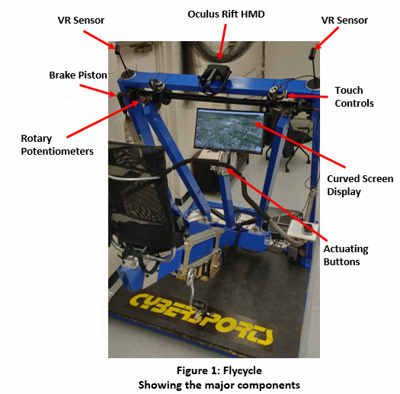they can track the motion of the Oculus Rift HMD (Head Mount Display) at all positions. The rotary potentiometer on the touch controllers are replaced by the Flycycle potentiometers to give all motion control.

Two games are tested on the Flycycle both with and without the VR integration. The first game is a **Flight simulator**. Here the planes pitch is mapped from the pitch of the Flycyle and the same is done for the roll. The angle of the view can be controlled by the buttons on the Flycycle. The simulator is equipped with information like the elevation of the plane, eye height, the roll and the pitch angle with respect to the ground, etc. This gives the user a realistic experience of actually flying a plane. Moreover, the flight simulator is integrated with google earth and therefore you could even fly over your own house. Upon integrating it with Oculus, the experience gets even better. Because of the HMD, the user gets a 360 degrees immersion of the world and gets to control the plane while exercising. Figure 2 (a) shows the view of the flight simulator passing over the University of Maryland. To see the video demonstration, of the simulator, please click [here](https://www.youtube.com/watch?v=o-xOCrdsLkI) and for VR integrated flight simulator, please click [here](https://www.youtube.com/watch?v=6Vby8e83910&).

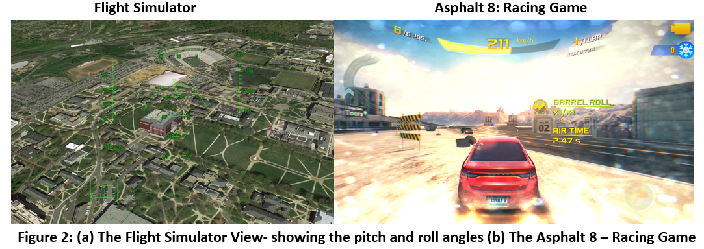The second game is **Asphalt 8**. This is a racing game and it is chosen as the game in 2D itself is very immersive. Plus, it also opens an avenue for different people to compete in the game. The direction of the motion of the car is controlled by the roll of the Flycycle while the pitch controls the barking. The different buttons mounted on the Flycyle actuate the nitro and the different camera angles. Similar, to the previous game, the VR integration gives a 360-degree immersion and helps the user exercise while enjoying the game. Figure 2(b) shows a screenshot of the car racing through the track. To see the video demonstration, of the game, please click [here](https://www.youtube.com/watch?v=j1T--EIB80Y&). The GitHub handle for the project can be found [here](https://github.com/anirudhtopiwala/Flycycle).

## 3) Project Plan and Milestones

Now that the basic implementation of playing a game on the Flycycle with VR integration is complete, we propose to move on to the next part of the project. There ae two objectives here. 1) To develop coursework for the Flycycle. This would further include am exhaustive tutorial on Unity and game development. 2) To use the Flycycle for rehabilitation Purposes such as for pediatric patients with muscle dystrophy.

The course work will be divided into two parts. The first one would be on the Flycycle and the other would be on Unity. Both of these will be taught simultaneously so that the student is able to develop games for the Flycycle by the time he first part is completed.

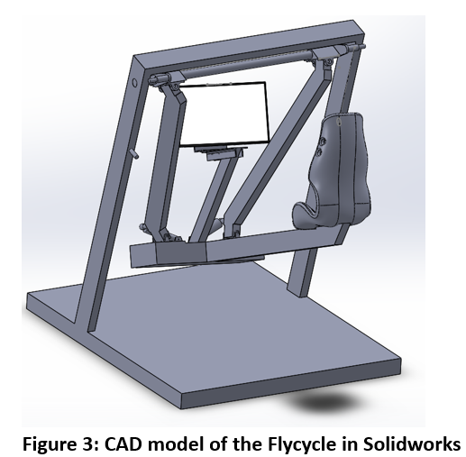For the **Flycycle section**, the course will be divided into 4 parts as follows:

1. **Brief Overview and Safety:** Here the students will be given a brief introduction to the Flycycle. After that the video demonstrationof the existing games on the Flycycle will be shown to bring the excitement level up. After that, a safety session will be organized wherein, all the critical components which could be hazardous would be explained to the students.
2. **Mechanical Overview and Designing:** Here the mechanical design of the Flycycle will be taught. The students will be tasked with assignments on force calculation for the force sensors. They will be also taught on how to model the Flycyle in Solidworks and how to make new components for the Flycycle. Figure 3 shows the already existing CAD model of the Flycyle.
3. **Software System and Integration with Unity:** Here the electronics and the software used will be explained thoroughly. Students will have assignments on tweaking both the rotary potentiometers to get the best roll and pitch mappings. Also, by this time students would have learnt how to make games in Unity. Here will we teach on how to integrate these games with the Flycycle.
4. **Competition:** This would be the final phase of the course. We will organize a competition wherein all the students will develop their own games which can be played on the Flycycle. The student with the best score from the peer group will win the competition.

For the **Unity section**, there will be three parts and all of them will be hands-on:

1. **Installation and Familiarization with Unity**: Students will be shown step by step procedure on installing the unity software. There on, students will be given an interface overview of the software, followed by understanding the Game Objects and the Components. After that simple games like rolling a ball and making 2D UFO games will be taught.
2. **Flight Simulator Games**: As unity is very broad scale and there are multiple types of games that can be learned, we will stick to the flight simulator games. Although, students would be encouraged to learn other games as well. Here students will learn on creating the airplane physics in Unity and the basics of weight and forces to produce believable aircraft physics.
3. **Integration with VR:** Here students will learn on how to create games in VR. As we already have the Oculus HMD setup, students will get the opportunity to test all the games they make. Students will be asked to develop a game in VR which could also be independent of the Flycycle for this part of the course. This would make the completion of the Unity section of the course. Information on further tutorials would be given as this point in time.

The second avenue is using the Flycycle for rehabilitation purposes.

To summarize, the two milestones for the project are; 1) Developing Coursework for the Flycycle, which would also contain learning Unity as a subcomponent. 2) Carry out research on rehabilitation uses for the Flycycle.

## 3. Budget So Far

